FACTSET ACTIVATION INSTRUCTIONS - ENDICOTT
FactSet Activation Link
Click on the link above to access the Academic Procurement page. Make sure to signup with your Endicott email address. You will need to declare your anticipated graduation year.
Once approved, this will activate your FactSet user ID and password process.
Academic institutions will be using FactSet for the Web. You can use it in a browser or download the web application.
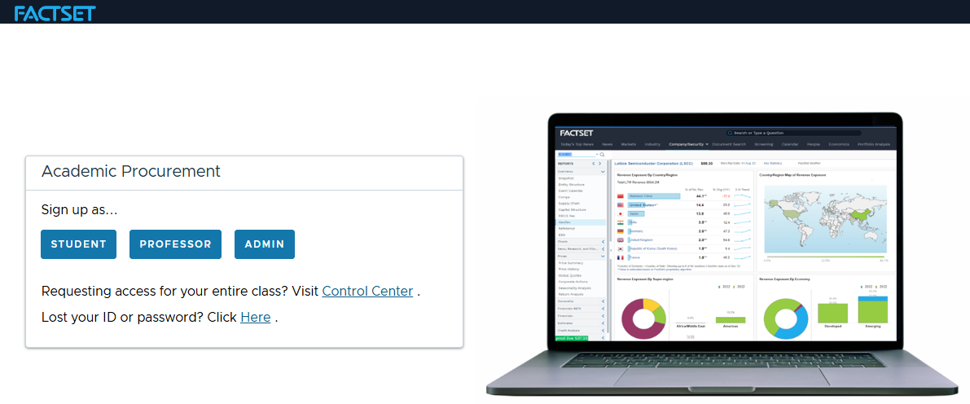
Once you are signed into FactSet, here are the instructions on how to add FactSet 365 to Excel:
The Excel FactSet 365 add in is best used on Google Chrome. The add-in can be downloaded by following these steps:
- Go to www.office.com - signing into OneDrive with your Endicott ID (this might be an extra step )
- Open a new or existing Excel File
- Navigate to Home > Add-ins then click More Add-ins
- Under Store, use the Search function to look for FactSet 365, then click Add
- You will need to sign into Factset in Excel to access the add-in functions.
